Assignment day 2

**TASK: 01**

**Create directories which would have the following structure by using only mkdir command:**

**HIERARCHY:**

consultadd/

|-- Python

| `-- Django

| `-- restframework

|-- java

| `-- springboot

|-- javascript

| `-- angular

| `-- react

|-- SQL

| `-- mysql

`-- bootcamp

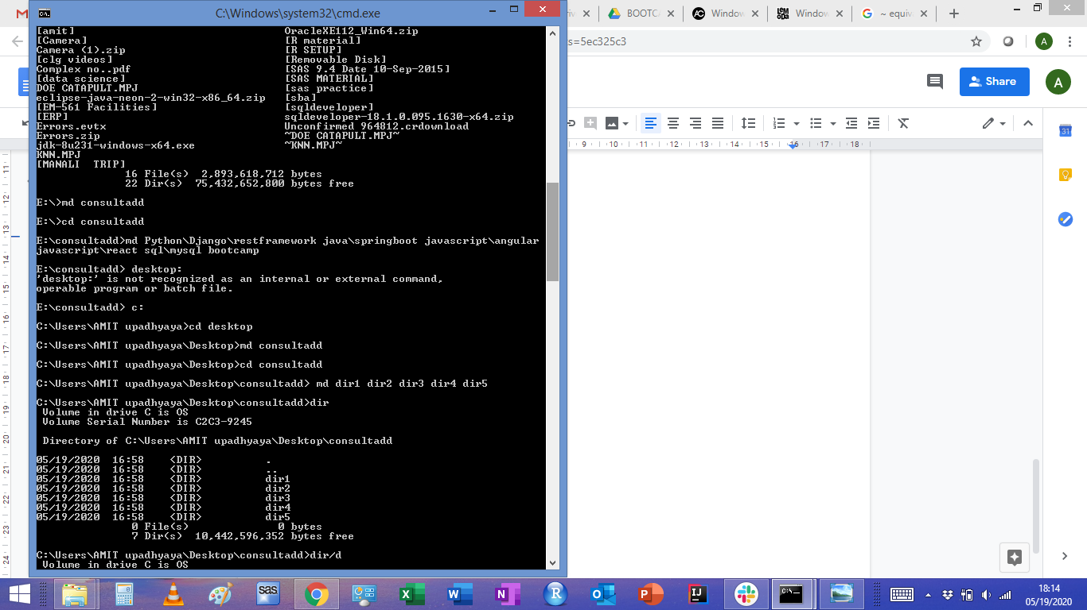

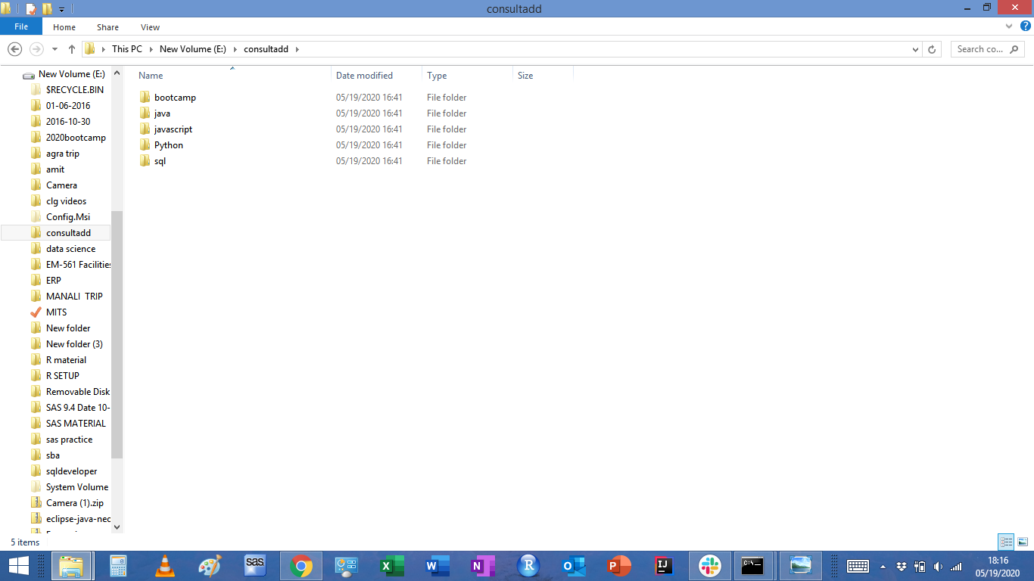

**TASK 02:**

* Create Directory called consultadd
* Inside that create 5 more directories named them as dir1, dir2, dir3, dir4 and dir5
* What would be the output of Long Listing after creating these directories?
* List all the directories with ls and echo * and see the difference.

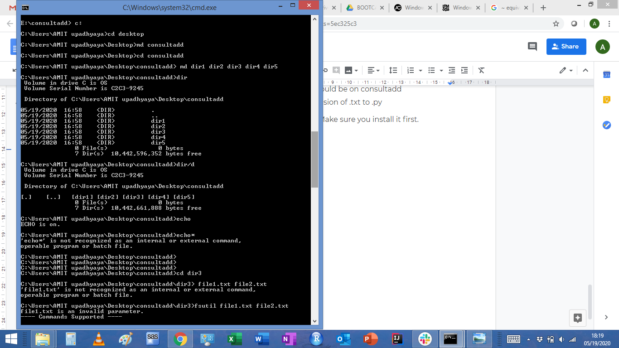

* Create a 2 files named them file1.txt and file2.txt inside dir3

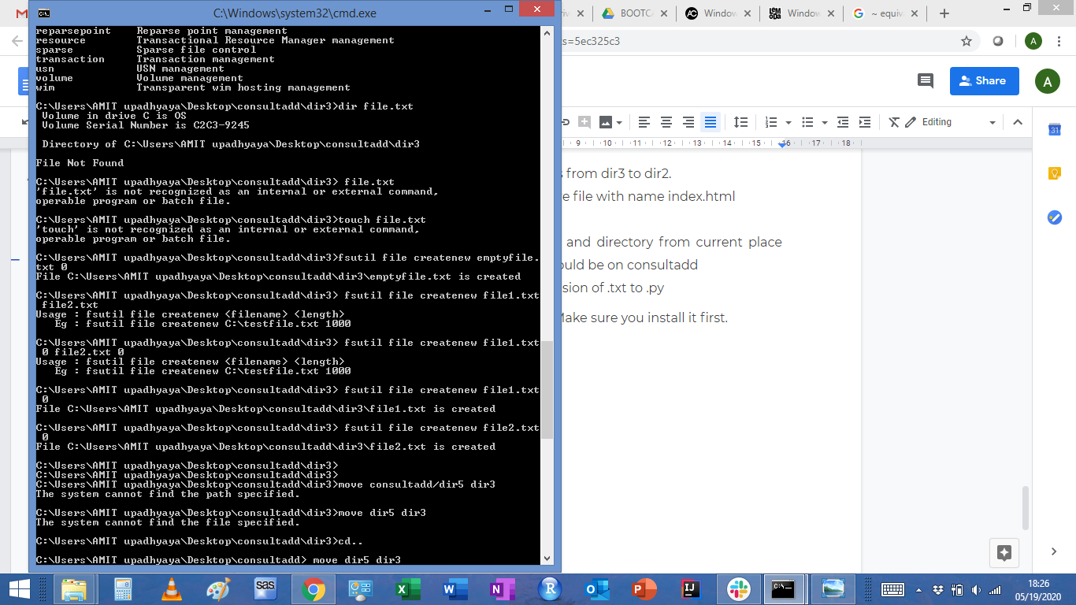

* Move dir5 into the dir3
* Remove dir 3 after moving all files from dir3 to dir2.

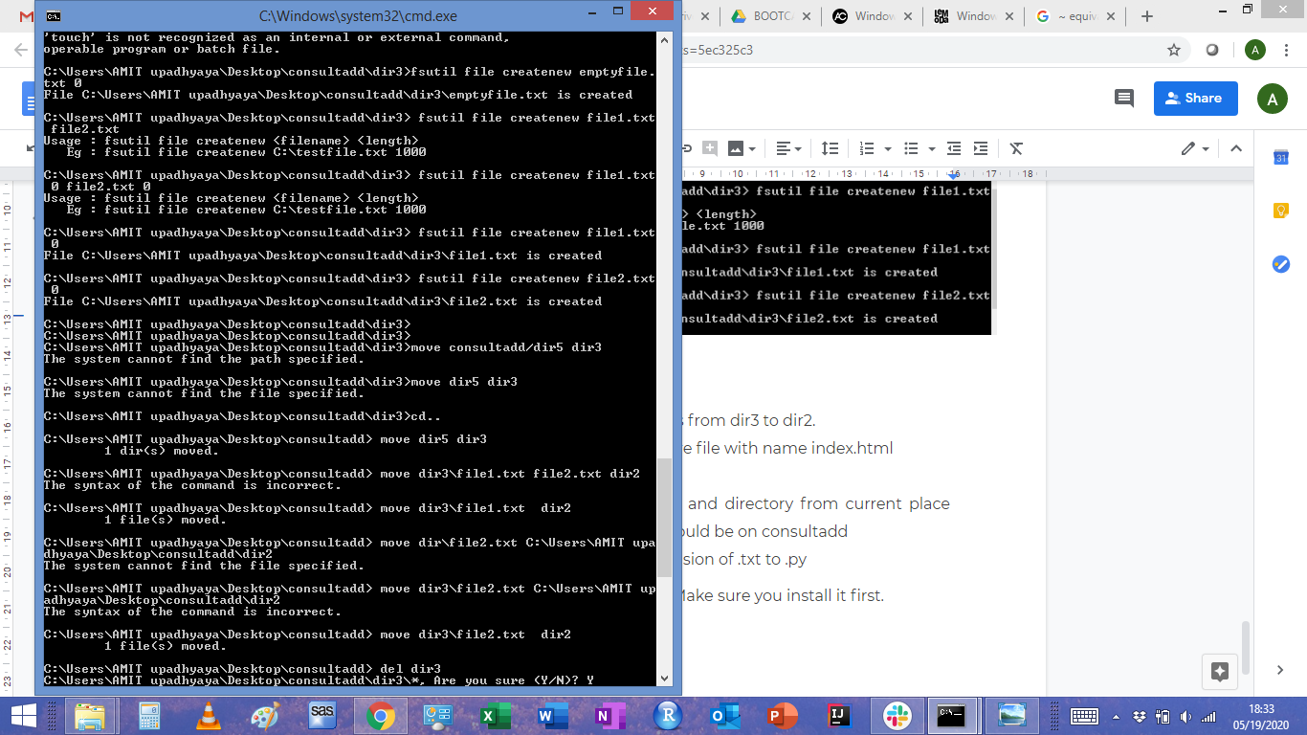

* Go to the dir2 and create one more file with name index.html
* Move to top level directory
* Check the permission of all files and directory from current place make sure when you do **pwd** it should be on consultadd
* Rename all files of dir2 with extension of .txt to .py

**HINT:** Use Rename command - Make sure you install it first.

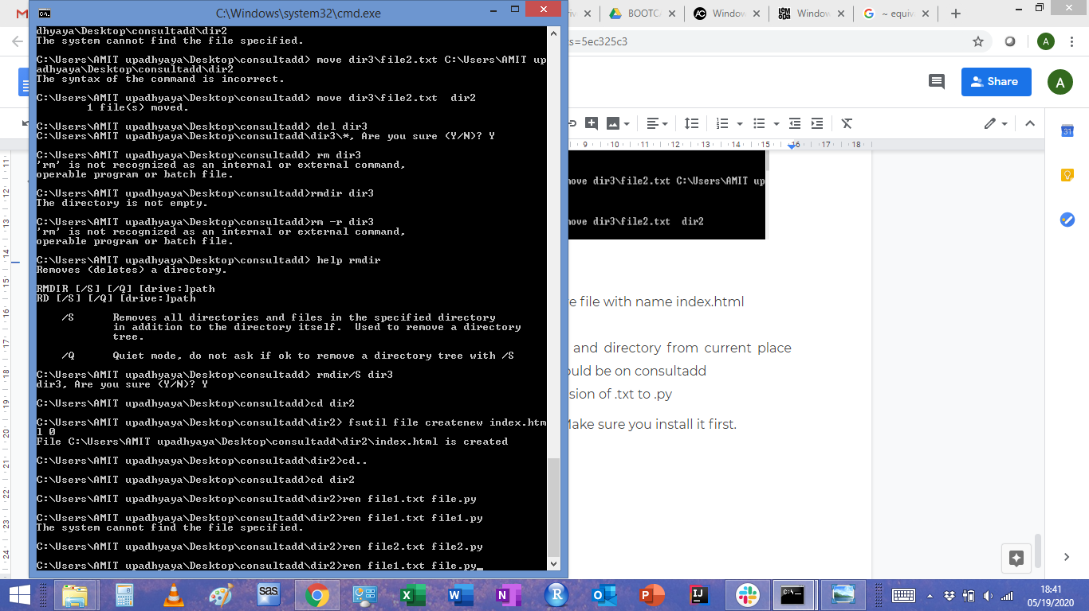

**TASK: 03**

* What is Nano Editor?

To work on the command line sometimes it is required to edit text files, NANO is easy to use as a text editor. It includes all the basic functionality you’d expect from a regular text editor, like syntax highlighting, multiple buffers, search and replace with regular expression support, spell checking, UTF-8 encoding, and more

* + How to create a sample file in Nano Editor?

$ nano [file-name]

* + How to save file?

CTRL+O

* What is Vi Editor?

Screen oriented text editor for mac and unix OS

* + Operation in Vi Editor

Two modes :-

Command mode- This mode is responsible to perform administrative task such as saving the files, moving the cursor, copy paste, find and replace etc

Insert mode- Through this mode we can enter text into the file.

**TASK: 04**

* Type **finger** to see your account and name.
* Type **cal** to see this month’s calendar.
* Create a file and give a name random.txt to it with content into it which say “Hello Welcome to the Consultadd Inc Bootcamp”.
* Display the same content using **cat** command.

Unable to do it in windows .

**TASK: 05**

* Explain the workflow of the Internet in one paragraph.

So the Internet is basically a wire buried under the ground , it could be fibre optics or copper. When two computers are connected to this wire they can communicate to each other, these computers are called servers and the web pages are stored in it. Each of these servers has its own address that is called an IP address. When a request is raised from one server to connect to another, this IP address plays a role in finding that server. So In general laptops that we use are not directly connected to the Internet they are connected via ISP ( internet service provider). Flow of data over the internet is done through packets i.e when data is requested from one server to another it breaks into small packets and flows in sequence to recompile at the second server. Routers are used for not mixing up the data from different users.

* How LAN is different from the WAN network?

LAN stands for Local Area Network which covers small geographical areas like homes and offices whereas WAN Wide area networks cover large areas like cities, states. Group of LAN’s makes a WAN Network. Speed of LAN is higher than WAN and is cheaper. LAN networks usually have high bandwidth.

**GOOD WORK - AMIT**

**RIYAZ UL HAQUE**